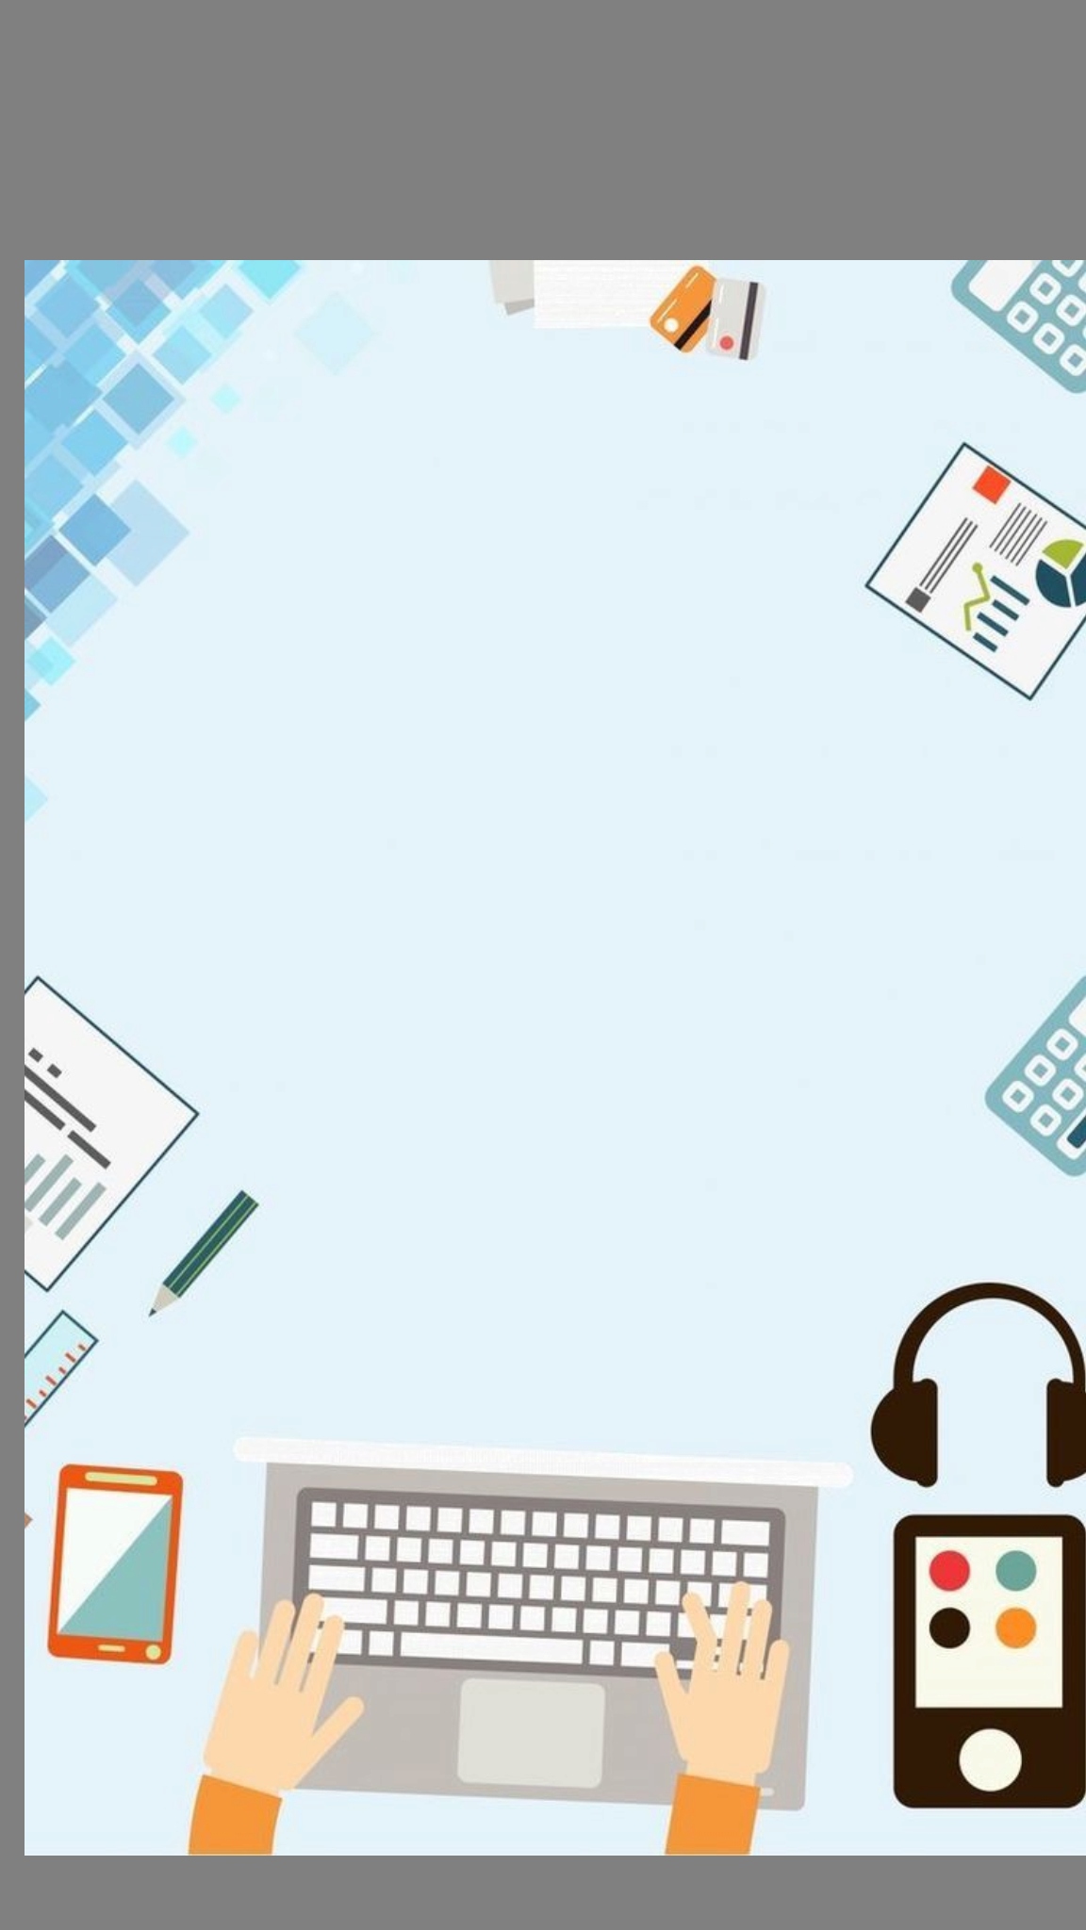
PROJECT REPORT
The Digital Divide Within: From Using Tools to Understanding Responsibility



Submitted by:
Name: Manishika
Reg. No: 25MIP10074
Course: DIGITAL LITERACY
Faculty: DR .Kannan S

Introduction

The project is based on completing a task for the Digital Literacy course, and I have been assigned the role of a Student Digital Ambassador. The project's objective is to comprehend and demonstrate the significance of digital literacy in the modern world. I have completed various tasks to learn about digital tools, online sites, digital communication, and cyber safety strategies.

The tasks included designing an infographic, developing professional online profiles, learning about coding and collaboration sites, email etiquette, and cybercrime awareness. All these tasks help to develop skills for students in the digital world.

Overall, this project has given valuable insights into digital literacy and how to effectively utilize digital tools.

ABOUT TASK 1

I designed a digital literacy awareness infographic using Canva. The infographic was designed to provide an effortless and direct demonstration to the students about digital literacy and its educational value. The infographic has key sections that provide definitions for digital literacy and showcase essential digital tools using Google Docs and GitHub while providing safe internet usage and email etiquette guidelines.

The design process for my infographic involved keeping the design clean. I was able to do this by using bullet points to keep the text short. This helped the viewers to see the information in a way that was appealing. I have discovered that the role of design is that it acts as a vital component that helps in conveying messages to people. When the information is presented in the correct way, everything will be fine.

The process of selecting the appropriate layout for the infographic to fit into the restricted space was difficult. I was able to understand the concept of digital literacy and communication using visual elements.

ABOUT TACK 2

In this task, I have developed my digital presence by creating profiles on GitHub, LinkedIn, and Kaggle. GitHub is used for sharing code and projects, and this will help me develop a strong portfolio in the future. I have also created a profile on GitHub with a README file, in which I have written about myself and my learning goals.

LinkedIn is a professional networking site, and students and professionals connect with each other on this site. I have also created a profile on LinkedIn and filled in the details of my educational background. This will help me develop a strong professional identity in the future.

Kaggle is used for practicing data science and machine learning concepts. This site will also be helpful in the future in developing my analytical skills.

In the next four years, I plan to develop these profiles with details of my projects, achievements, and skills. This will help me develop a strong digital presence and increase the chances of getting internships and job opportunities.

ABOUT TASK 3

In this task, I was asked to write about my experience using coding and collaboration platforms. In the coding section, I used the HackerRank platform and solved a beginner-level problem titled “Solve Me First.” This helped me understand the basic working of coding platforms and how problems are structured for practice.

In the collaboration section, I created a Google Form titled “Digital Literacy Awareness Quiz” consisting of five questions. I also viewed the form in Google Sheets to understand how efficient it was in collecting and analyzing the responses. This task helped me understand how digital platforms can be used for learning and collaboration. I can use coding platforms like HackerRank to enhance my problem-solving skills, while Google Forms can be useful for conducting surveys and collecting

ABOUT TASK 4

Ineffective communication of messages in the digital world can sometimes result in misunderstandings and adverse consequences. For example, if a student wishes to send an email to the professor using casual language and without a subject line, the professor might not respond favorably.

In this context, the student should use proper etiquette in sending the email, being polite and using proper content. This will help in conveying the message in the best way.

In this task, I have learned the significance of professional communication in the digital world. I have come to understand that messages should be written in the best way to maintain clarity, politeness, and professionalism.

ABOUT TASK 5

During my research on UPI fraud, I was surprised to learn that people can be easily tricked into losing money by using simple methods like fake calls and QR codes. Many people do not know that they do not need to put in their UPI PIN to receive money, which is one of the common ways fraudsters trick people.
This task has helped me realize the importance of being cautious while using digital payment platforms. One thing I have learned from this task is that I will never agree to any unknown payment requests and will never disclose my details to anyone.
This task has helped me learn about real-life cyber threats and the importance of being digitally aware in real life.

Conclusion

This project has also helped me understand the need for digital literacy in both academic and professional contexts. I have learned how to use different tools, develop a professional online identity, and communicate through emails. I have also learned the importance of being aware of cyber threats and how to remain safe online.
In general, this project has helped me develop both technical and ethical skills in the use of technology. These skills are important in the development of my future academic and professional pursuits.

References

- canva.com
- github.com
- linkedin.com
- hackerrank.com
- forms.google.com
- cybercrime.gov.in

